April 11, 2024

Dear Representatives of Indigenous Peoples,

With the reference to the letter from the President of the General Assembly dated 14 February 2024 and 9 April 2024, allow us to express our deep appreciation to the President of the General Assembly for entrusting us to conduct consultations on possible further measures necessary to enhance the participation of Indigenous Peoples’ representatives and institutions in relevant United Nations meetings on issues affecting them, in accordance with General Assembly resolution 78/189 of 19 December 2023.
We have the honour to invite your delegation to participate in an informal consultation that will take place on Wednesday, April 17, 2024, at 10:00 am in Conference Room 7. This meeting will provide an opportunity for Member States and Indigenous Peoples to express their views on possible further measures necessary to enhance the participation of Indigenous Peoples’ representatives and institutions in relevant United Nations meetings on issues affecting them. We would also be pleased to meet bilaterally with delegations upon request.
For additional details or any inquiries, delegations from Member States and Indigenous Peoples’ representatives and institutions may contact our experts Ms. Cassandra Morin from the Permanent Mission of Canada (cassandra.morin@international.gc.ca) and Mr. Eder Rojas from the Permanent Mission of Peru (erojas@unperu.org).
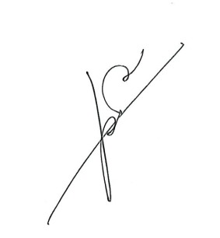
We remain committed to continue engaging on this important subject with all participants in the consultations and appreciate your continued support.
Please accept the assurances of our highest consideration.

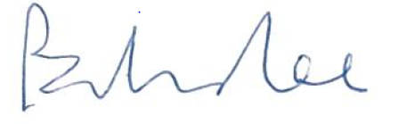

Ambassador Bob Rae
Permanent Representative of Canada to the United Nations
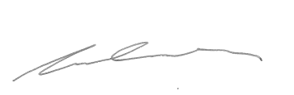

Dr. Claire Charters

Ambassador Víctor García Toma
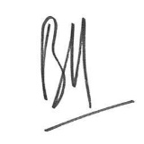
Permanent Representative of Peru to the United Nations

Mr. Belkacem Lounes

