Wellbeing of Older People and Enhancing Quality of Life in Hong Kong
Teresa Tsien
Honorary Consultant,
Research Centre for Gerontology & Family Studies
Hong Kong Polytechnic University

Hong Kong as an Aged Society
Since 2013, Hong Kong has taken over from Japan to lead the world in life expectancy (1). In 2023, Monaco has the highest life expectancy in the world, according to World Population Review, with an average age of 87. Hong Kong ranks second with an average longevity of 85(2).
With a longer average life expectancy, a persistently low birth rate as well as the baby boomers gradually entering retirement age, the number and proportion of older adults will gradually increase in Hong Kong, making the ageing trend more prominent. According to the Hong Kong Census and Statistics Department's population projection, the percentage of elderly persons aged 65 and above will trend up from 20.8 percent (1 in 5) in mid-2022 to 25.3 per cent (1 in 4) by 2028, and then to 35.1 per cent (1 in 3) in 2069. With a population of close to 7.5 million in 2023, the medium age is 45.6 for female and 44.2 for male. In 2022, according to the Global Economy, the total dependency ratio increased to 48.18%, which means 100 working age people aged 15-64 have to support 48 non-working age people younger than 15 and older than 64.(3) By 2024, the city will officially be a ‘super-aged society’, meaning more than 21 per cent of people are aged over 65. By 2034, Hong Kong will be ultra-aged, like Japan, with more than 28 per cent over 65. (4) The vast majority of the elderly live and age in the community with the support of their families and/or the Government. Only about 4% reside in residential homes. Furthermore, about three quarters of the older adult population (about 1.1 million people) are receiving different types of public financial assistance. The Hong Kong Government adheres to the ageing policy objective of promoting "ageing in place as the core, with institutional care as back-up", to enable older adults to live in dignity and to provide the necessary support to promote their sense of belonging, sense of security and sense of worthiness in the community.
Population aging represents a significant challenge for health and social care services. Older adults who engage in activities that offer a sense of purpose have significantly better physical and psychological health outcomes. There is preliminary evidence that purposeful activity interventions, particularly those that involved taking on a functional role, can improve well-being and quality-of-life outcomes in older adults aged 80+. (5)
In 2023-24, the Government's estimated recurrent expenditure on elderly persons has reached $123.1 billion, which is 70 per cent higher than the $71.0 billion in 2017-18. The total estimated recurrent expenditure on elderly cash welfare reaches $51.2 billion in 2022-2023, about 76% of the estimated expenditure on Social Security ($67.5 billion), and it demonstrates the Government's commitment to the elderly amid an ageing population.(6)

Services to promote ageing well in Hong Kong

In order to help older adults to age well in place, over the years, the government has proposed and supported a list of programmes and services as follows:

- Community and Social Services ( aged 60+)
- District Elderly Community Centres/Neighborhood Elderly Centres
The Elderly Centres provide diversified community support services for elderly persons and their carers in district level to encourage active participation of the elderly in community activities, such as retirement planning and promotion of gerontechnology as well as volunteer services.

- Senior Citizen card (aged 65+)
The Senior Citizen Card facilitates those aged 65 or above to enjoy concessions, discounts or priority services offered by government departments, public organisations and over 2 000 private enterprises. The Card encourages older adults to go out of their homes to participate in economic activities.

- Senior Citizens Day (aged 65+)
To show care and respect for our older adults, the third Sunday of November each year is designated in Hong Kong as Senior Citizens Day. Over 1,400 outlets throughout the 18 districts would offer concessions to holders of Senior Citizen Card for their purchases on the Day.

- Opportunities for the Elderly Project
Through subsidizing various social service organizations, educational institutes, district organizations to carry out a wide range of programmes providing various opportunities for the older adults to unleash their potentials, further their contribution to society and cultivate a sense of self worthiness.

- Financial services
- Social Security

Old Age allowance – non-means-tested for elderly persons aged 70 or above (currently benefitting 220,000 people).

Old Age Living Allowance (OALA)/Comprehensive Social Security Assistance (CSSA) – means-tested (OALA) for those aged 65 or above; currently benefitting around 430,000 people or the means-tested (CSSA) for all ages; currently benefitting 170,000 elderly recipients aged 60 or above.

- Pilot Scheme on Community Care Service Voucher for the Elderly (aged 60+)
Adopts a "money-follows-the-user" co-payment approach to provide subsidy directly to eligible elders, enabling them to choose the service provider(s), service types such as day care or home care services and packages which best suit their needs.

- Silver bonds/Public annuity scheme (aged 60+)
The government had offered Silver Bonds for sale to those aged 60+ with higher fixed interest rate to boost their income in an uncertain economic environment. Hong Kong Mortgage Corporation Annuity Plan, the first public annuity scheme of Hong Kong, was launched to offer monthly lifelong streams of income to the annuitant.

- Elderly Reverse Mortgage Programme (aged 55+)
The Reverse Mortgage Programme enables people aged 55 or above to use their residential properties in Hong Kong as security to obtain reverse mortgage loans.

- Building Maintenance Grant Scheme for Needy Owners (aged 60+) Building Maintenance Grant Scheme for Needy Owners is managed by Urban Renewal Authority offers financial assistance of a maximum grant of $80,000 to needy owner-occupiers to repair and maintain the safety of their self-occupied flats and common areas.

- Transportation (60+)
$2 Public Transport Fare Concession Scheme enables 1.12 million elderly persons aged 60 or above to travel on general MTR lines, franchised buses, ferries and most green minibus routes anytime at a concessionary fare of $2 per trip. This Scheme promotes Hong Kong as a caring and inclusive society by encouraging the older adults to stay active to participate in community activities.

- Education
The Elder Academy Scheme is an education and social inclusion initiative to provide access to learning opportunities in schools and university campuses and are aimed primarily at older adults who have had little or no education. The scheme optimizes the use of existing educational facilities to promote both lifelong and initial learning for older adults, encouraging participation and helping to maintain physical and mental wellbeing and lead a fulfilling life and achieve active ageing. School and university students are engaged in the scheme to promote civic education and intergenerational understanding.
- Gerontechnology
Information and Communications Technology (ICT) Outreach Programmes for Older Adults are implemented to allow older adults to experience the use of ICT in enhancing their quality of life. The activities include using smart robots to show tutorial videos on digital technology, and using drones to conduct virtual community tours for older adults. Funded Non-Profit Organizations have been organising mobile outreach service station activities in various districts in Hong Kong to proactively introduce common mobile applications to the elderly and answer their questions on the use of smartphones.

- Retirement in the Mainland
Retirement in the Mainland for older adults who choose to retire in the Mainland may continue to receive help under various initiatives. These include: the Guangdong Scheme, which provides Old Age Allowance for eligible elderly persons who choose to live in Guangdong; the Portable Comprehensive Social Security Assistance (CSSA) Scheme, which allows eligible elderly CSSA recipients to continue to receive cash assistance if they choose to retire in Guangdong or Fujian; and the Pilot Residential Care Services Scheme in Guangdong, which provides elderly persons waitlisting for subsidised residential care places in Hong Kong with an option to choose to live in the two elderly homes located in Shenzhen and Zhaoqing run by Hong Kong non-governmental organisations
(G) Carer support service
(1) Living Allowance for Carers of the Elderly Persons from Low Income Families
The Allowance provides carers of older adults from low-income families with an allowance of $3,000 per month to help supplement their living expenses so that elderly persons in need of long-term care can, with the help of their carers, receive proper care and age in their familiar community.
(2) Designated Hotline for Carer Support
A 24 hour hotline service which aims to reduce the stress and burden induced by daily caregiving, and enhance their caring capability continuously. It provides instant support by phone managed by professionals including crisis intervention and outreaching service to those facing emergency situation without support.
(3) Support for Carers Project
Aims to provide basic training to frontline property management personnel to equip them with knowledge on how to identify and assist needy elderly persons and carers.

- Health care services (aged 70+)

- Elderly Health Care Voucher Scheme are provided for each elderly person aged 70 or above. The $2,000 voucher may be used for private primary and preventive care services offered by medical practitioners, Chinese medicine practitioners, dentists, chiropractors, nurses, physiotherapists, occupational therapists, radiographers, medical laboratory technologists and optometrists.

- Government Vaccination Programme (65+)
Free seasonal influenza vaccination is provided to elderly people aged 65 or above. They can choose to have free vaccination at the public hospitals, clinics or they can also receive subsidised vaccination at private clinics through the Elderly Vaccination Subsidy Scheme, or free vaccination at residential care homes for the elderly under the Residential Care Home Vaccination Programme.

- Primary Healthcare Blueprint
The objective of the Blueprint is to shift the focus of the current healthcare system from curative treatment to prevention of diseases, thereby improving the overall health status of the population, providing accessible and coherent healthcare services, and establishing a sustainable healthcare system. Improving primary healthcare services will help alleviate the pressure on the secondary and tertiary medical services in the longer run.
- Subsidized Traditional Chinese Medicine (65+)
Older adults 65+ can pay subsidized rate on treatment-related Chinese medicine general consultation (with 5 doses of prescribed medication), acupuncture service and bone-setting/tui-na treatments in 18 Chinese Medicine Clinics.

- Age friendly city
In 2008 the Hong Kong Council of Social Service (HKCSS) established the Age-Friendly Hong Kong Steering Committee to promote the concept of age-friendly city. In 2016, the Hong Kong Chief Executive’s Policy Address featured building an age-friendly community as a specific policy focus. The Hong Kong Jockey Club funded and conducted a baseline research, recommended a framework and aroused public awareness by a bottom-up and district-wide approach to engage four universities and the support from the district councils and the HKSAR government district offices. In 2020, all 18 districts in Hong Kong have successfully joined the World Health Organizations Global Network for Age Friendly Cities and Communities.

Case Sharing of the Institute of Active Ageing (Research Centre for Gerontology and Family Studies), Hong Kong Polytechnic University
In 2002, World Health Organization (WHO) issued a policy framework on active ageing to support local governments in developing and strengthening health and social policies in an ageing world (7). An active ageing policy is defined as “optimizing opportunities for health, participation and security in order to enhance quality of life as people age”. It considers the biological, psychological, behavioral, economic, social and environmental factors in the life of a person to determine health and well-being in later years.

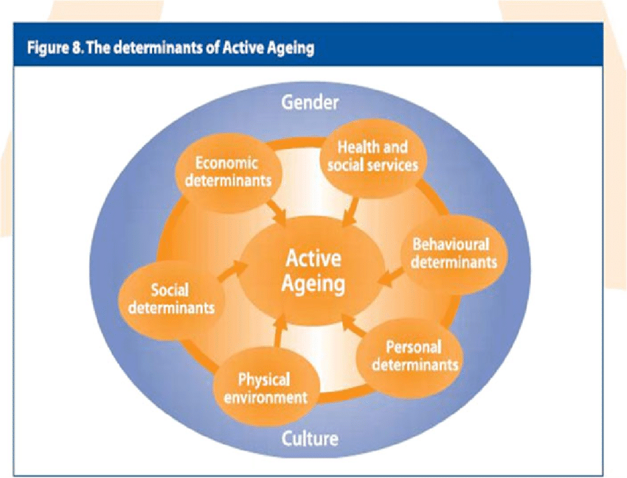

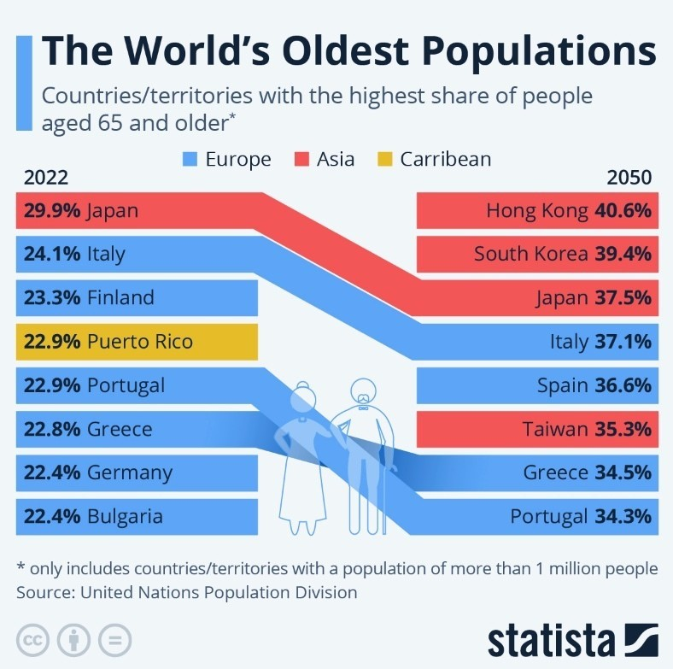
According to a 2012 United Nations report (8), Hong Kong is predicted to be the country or region with the fourth oldest population in 2050. The World Economic Forum also projected that Hong Kong would top the list to have 40.6% of people aged 65 and older by 2050. (9)
The Institute of Active Ageing (IAA) was established in 2010, hosted by the Faculty of Health and Social Sciences (FHSS) of the Hong Kong Polytechnic University (PolyU). IAA viewed Hong Kong’s large, gradual demographic change as an excellent opportunity to support the city’s development into a society that is better equipped to meet the needs and potential of its ageing population. PolyU is an application-oriented tertiary education institution with a long tradition of emphasising the application of innovative research and practices for the betterment of society. With the strong multi-disciplinary teams of 60 faculty members from 14 departments and units specializing in ageing education, research and product developments, the university’s proactive stance through IAA to promote the notion of active ageing and embrace the opportunities and challenges posed by an ageing society through interdisciplinary research, education, and practice is timely.
IAA is committed to research excellence and innovation in the key areas of ageing, interdisciplinary education related to gerontology, and evidence-based practices for the promotion of active ageing. The Institute adopts a unique and comprehensive model in the promotion of active ageing by encompassing education, research and practice from all fundamental dimensions of everyday life for older adults. In 2023, the IAA was renamed to Research Centre for Gerontology and Family Studies (RCGFS). (10)
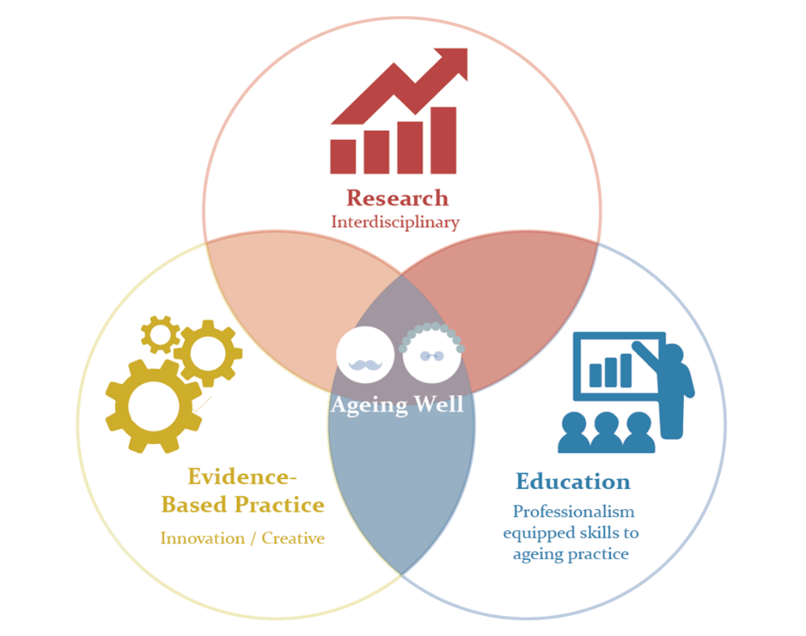
With three interlocking, interdisciplinary strategic areas of research, education, and practice, the IAA (RCGFS) has the following aims:
- Interdisciplinary Research
To create a platform to encourage and assemble scholars, researchers, and practitioners from 23 disciplines across PolyU under the broad categories of health and human services, finance and business, policy and management, design, engineering and technology, environmental sciences and biotechnology, textiles and clothing, and leisure and recreation to create synergistic opportunities for innovating cutting-edge research on ageing and interdisciplinary educational programmes related to gerontology such as total wellness, age-friendly environments, and gerontechnology. The five research foci are: Senior wellness, Ageing and Family, Digital Inclusion and Gerontechnology, Theory-Based Model Building and Age-Friendly Environment
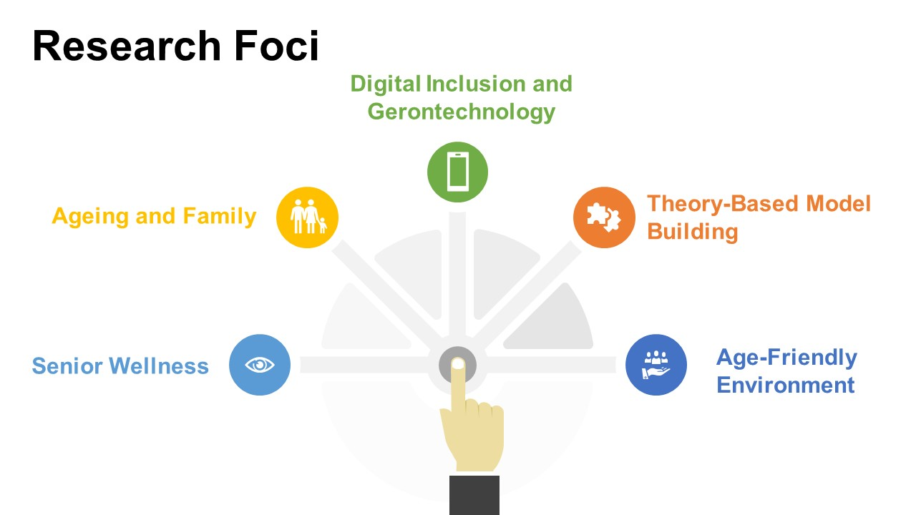

- Ageing Well Education
To create an interdisciplinary undergraduate programme in Applied Gerontology which will provide well-rounded professionals with competencies and attributes necessary to meet the emerging needs of the ageing society and be able to work with the diverse population of older adults. A full-time self-financed top-up degree programme was offered in 2012. Given the overwhelming response to the programme and the high employment rate of its graduates, the Hong Kong University Grants Committee and PolyU decided to make this a UGC-funded programme starting in 2017. The Programme is committed to developing interdisciplinary education to produce graduates with a well-rounded understanding in the areas of
- physical and living environments
- product and clothing design
- business and finance
- social policy and services
- technology and engineering
- science and traditional Chinese medicine
- health and social care
- Evidence-based Practice
IAA (RCGFS) offers lifelong education, evidence-based volunteer work and gainful employment to 5,000+ third age members who are aged 50+.
Lifelong education facilitates older adults to stay engaged, healthy and secured in society and has been proved to help to maintain quality of life in the physical, mental and social health aspects. The opportunity to further engage in education allows older adults to develop new skills and confidence which help them to stay connected with the community and enhance community well-being. The benefits of lifelong education among older adults can help them to achieve healthy ageing and to age with dignity.
The empowerment of older adults encourages their sharing of knowledge, insights, and experiences. From the affirmative findings of the various research projects, IAA (RCGFS) has identified evidence-based practice which can be transferred to meaningful volunteer work. Volunteering and community service not only offer practical aid and goodwill to the needy and underprivileged groups, but it can also give a sense of satisfaction to volunteers. Volunteering encourages interaction between different generations and people from diverse backgrounds, which can improve mutual understanding and respect.
Some older adults prefer to continue to work after retirement, either to restore a sense of self-fulfillment or for a financial reason. IAA ((RCGFS) offers skills development workshops, training programmes and job-matching service to help older adults to transition back into the workforce. IAA (RCGFS) has developed an extensive network with various NGOs, corporations in the business sector to develop a comprehensive older adults human resources database to identify job placements effectively.

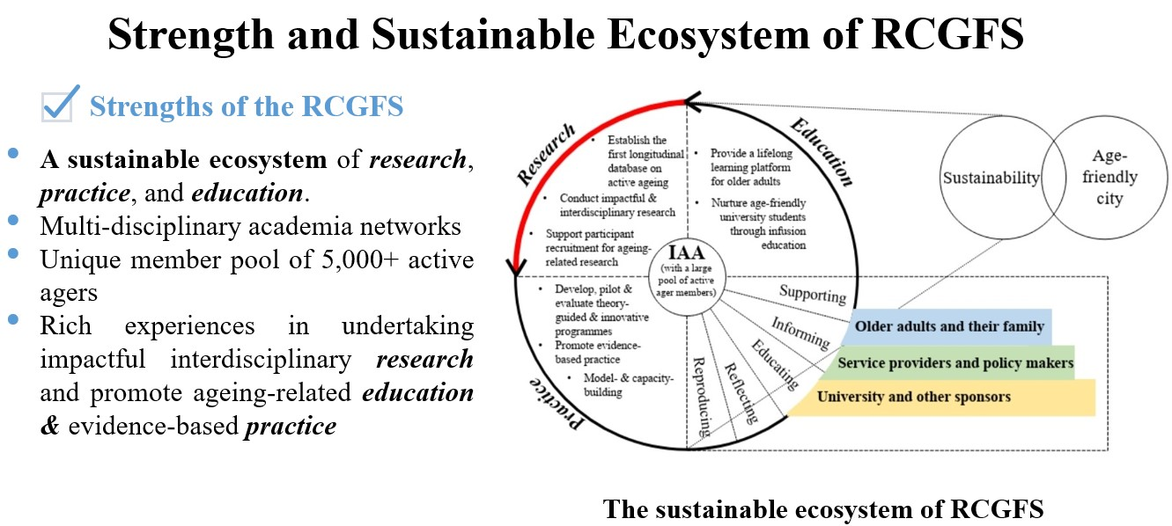

Conclusion and Recommendations
Hong Kong is predicted to become a super-aged society in 2024 when 21% of the population will be aged 65 and above. Hong Kong is at the threshold of a large demographic shift as the generation of baby boomers starts to retire. Active ageing is a key pillar of ageing well with quality of life, to delay the onset of diseases and sickness. As much as the Hong Kong SAR Government has provided strong financial support to develop policies and services to prepare for an ageing population, I would like to make a few recommendations to address the holistic approach to enhance the quality of life as people age

  - Promote self-efficacy among older adults
Some strategies to promote self-responsibility include: public education; involving older persons in the making of decisions and setting of expectations for how they will live; enhancing public access to information on health and wellness; and fostering self-efficacy among the elders through the acquisition of personal skills.
  - Respect for older adults
Elders have contributed to society throughout their lives and deserve to be treated with dignity and respect in their old age. Respecting elders also sets a good example for younger generations, teaching them the value of empathy, compassion, and kindness. Respecting elders is not just a matter of good manners; it is also a moral obligation. Education can also play a role in fostering respect for elders, with schools and universities teaching students about the importance of intergenerational relationships and the contributions that elders make to society.

  - Improve images of ageing
To enlist the support and co-operation of the mass media in changing the community mindset about the stereotypes of older adults. Older adults are empowered to be proactive in establishing a positive image by pursuing continued education, extended employment, and volunteerism.

  - Bridge generational divide
In the 76th General Assembly of the United Nations, Secretary-General emphasized the global wakeup call is to bridge generational divide.
One factor contributing to generational divide is ageism and generational gap. Intergenerational programmes should be further promoted in schools and senior centres to create platforms to encourage mutual understanding and exchange of life experience between the old and young.

  - Create supportive and age-friendly environment
An older person friendly environment should safeguard the safety and enhance the functional independence of older persons to focus on eight domains of livability, especially in the domains of social participation, respect and social inclusion, civic participation and employment, communication and information. The concept of universal design should be widely practised.

  - Gerontechnology
Gerontechnology, combining gerontology with technology, is one of the means of ensuring the necessary safety, independence and other essential factors are in place to enable the elderly to age well in the community as well as to improve their quality of life. The market of gerontechnology in Hong Kong is small and the variety of products is limited due to the lack of awareness of its importance, lack of human resources, etc. A more comprehensive ecosystem for gerontechnology in the Greater Bay Area with more research investment and collaboration among different stakeholders (elderly users, academics, researchers, service providers, NGOs and the private sector) can be considered and promoted.

  - Setting up an Inter-departmental committee on Ageing in Hong Kong
Holistic aging is a philosophy that looks at all aspects of a person as they age, including their mind, body and soul, finance, living arrangement, welfare, leisure activities, transportation, etc. An inter-departmental committee on ageing of the HKSAR government is proposed to have representatives from different departments to discuss and plan for support and services for older adults. This will ensure a concerted and holistic territorial response in deliberating and recommending relevant policy directions on ageing issues. This inter-departmental committee will stress the interdependent but functionally differentiated roles of the various stakeholders that are crucial in ensuring the well-being of older adults in HK. Thus, the responsibility for preparing for old age is to fall primarily on the individual, with the family and community forming the first and second lines of support respectively. The committee’s role includes providing a policy framework, infrastructure, and the necessary resources to boost the private and voluntary welfare sectors.

References

- Ni, M, et al (2021) Understanding Longevity in Hong Kong: a comparative study with long-living, high income countries. The Lancet, Public Health Vol 6. Issue 12. E919-E931, Dec 2021
- Evening Standard 19 September 2023
- The GlobalEconomy.com
- Lou,V (2020) Bulletin of the University of Hong Kong May 2020 Vol 21, No.2
- Owen, R., et al. (2022) Enhancing Older Adults’ Well-Being and Quality of Life Through Purposeful Activity: A systematic Review of Intervention Studies Gerontologists.
- Legislative Council Panel on Welfare Services – Cash Welfare for the Elderly July 2022
- WHO (2002) Active Ageing: A Policy Framework
- United Nations, Department of Economic and Social Affairs, Population Division (2013). World Population Prospects: The 2012 Revision, Highlights and Advance Tables. Working Paper No. ESA/P/WP.228.
- Ageing and Longevity: The World’s Oldest populations (2023) World Economic Forum
- https://profile.cpce-polyu.edu.hk/en/publications/healthy-ageing-and-lifelong-learning-in-hong-kong

