2018 New Year Greetings from the Secretariat for the Convention on the Rights of Persons with Disabilities (SCRPD)

In 2017, a number of ‘transformative’ initiatives were taken by the international community to make the 2030 Agenda for Sustainable Development a reality by, for and with persons with disabilities.

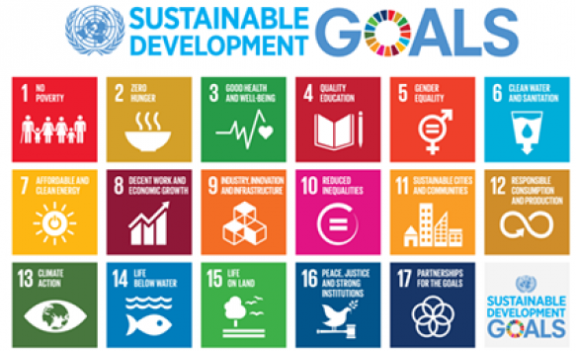
The 2030 Agenda with the principle of “leaving no one behind” calls for immediate action toward inclusive society and development, taking a “people-centered” approach. Our work is dedicated to support action by Governments, other UN offices, civil society, in particular, persons with disabilities, academic institutions, and the private sector to make the Sustainable Development Goals (SDGs) a reality for ALL, including persons with disabilities, in line with the UN Convention on the Rights of Persons with Disabilities.

As the international community, we need to make every action, every decision and every progress in the SDGs be accessible by, for and with persons with disabilities.

Let us revisit our progress last year:

To respond to the General Assembly resolution 69/142, rich progress was made in evidence-based research on the situation of persons with disabilities in preparation for the first-ever United Nations Flagship Report on Disability and Development. The SCRPD is addressing all SDGs through the SCRPD Expert Network and its Disability-Inclusive SDG Working Group to continue its priority efforts to advance research on disability and development. The UN Flagship Report on Disability and Development: Realizing the SDGs by, for and with persons with disabilities will be issued this fall.

Furthermore, a new General Assembly resolution on women and girls with disabilities was unanimously adopted in November last year. The resolution is the first of its kind with a thematic focus of the CRPD, to pursue a more accessible and inclusive society for all. The General Assembly also proclaimed 23 September as the International Day of Sign Languages to raise awareness of the importance of sign language in the full realization of the human rights of people who are deaf. The Day will first be observed in 2018.

The highest number of participants was recorded at the 10th session of the Conference of States Parties to the CRPD (COSP) this year - more than 1,200 delegates and observers from Member States, UN entities, academia, NGOs, and Disabled Persons’ Organizations that filled every meeting and every side event at the Conference, a true testimony of the energetic multi-stakeholder engagement and new platforms on disability-inclusive SDGs in alignment with the UN Convention on the Rights of Persons with Disabilities.
We continued to promote accessibility both within and outside the United Nations system. We supported the President of the UN General Assembly as he championed accessibility in his office. During the high-level week of the 72nd session of the UN General Assembly, the President of Ecuador and the Vice-President of Argentina, who are wheelchair users, made their statements from the same Rostrum as other world leaders, making progress in accessibility of the General Assembly Hall.

We also dedicated our efforts to strengthen the capacity building of those who engage in disability-inclusive development through the UN Voluntary Fund on Disability and the UN Partnership on the Rights of Persons with Disabilities (UNPRPD). We need more action on the ground and to engage society -ALL its members- to make society and development more inclusive and accessible. Let us bring more good practices to the forefront so that we can inspire ourselves and our colleagues.

Just last month in December, we commemorated the International Day of Persons with Disabilities with an official event and discussion: Member States, including Bulgaria, Ecuador, Japan, New Zealand, Republic of Korea, and Turkey discussed their leadership in disability-inclusive 2030 development agenda- Students from the University of Tokyo discussed their practical ideas to support the implementation of the SDGs inclusive of persons with disabilities. The Day advocated for just and equitable society by, for and with persons with disabilities.

Moving forward in the new year:
For any successful implementation of the global agenda, a robust monitoring and evaluation mechanism is key. In 2018, we will have a series of discussions and events to further explore better options for implementation and monitoring and evaluation– one of the first events will be a panel discussion on evidence-based approach to the mainstreaming of disability during the 56th Session of the Commission for Social Development in January.

The 11th session of the Conference of States Parties will take place from 12-14 June to further advance the implementation of CRPD and the disability-inclusive global agenda. In July, the High Level Political Forum on Sustainable Development, the central mechanism for the follow up of the 2030 Agenda, will be held under the theme: ‘Transformation towards sustainable and resilient societies’. Please join us in person or in a virtual space!

We wish you a joyful and prosperous new year!!

Secretariat for the Convention on the Rights of Persons with Disabilities (SCRPD)
Division for Social Policy and Development (DSPD)
UN Department of Economic and Social Affairs (DESA)

BE INFORMED! GET INVOLVED!
Find out more about the work of the United Nations for persons with disabilities:

Subscribe to the UN Enable Newsletter: http://bit.ly/unenablenewsletter
Facebook: http://on.fb.me/1xtJPMO
Twitter: https://twitter.com/UN_Enable
Web: http://www.un.org/disabilities
Email: enable@un.org

