**UN Enable Newsletter**

February - March 2018

The UN Enable Newsletter is prepared by the Secretariat for the Convention on the Rights of Persons with Disabilities (DSPD/DESA) with input from UN offices, agencies, funds and programmes, as well as from civil society organizations, including organizations of persons with disabilities. It is also available online at: [www.un.org/disabilities](http://www.un.org/disabilities).

**In this issue:**

- The CRPD

- In the Spotlight

- News from UN Headquarters

- News on regional intergovernmental meeting

- News from other UN entities

- Calendar of international disability events

- Other news

**THE CONVENTION ON THE RIGHTS OF PERSONS WITH DISABILITIES (CRPD)**

**[Status of the CRPD]**

**177** ratifications/accessions and **161** signatories to the CRPD

**92** ratifications/accessions and **92** signatories to its Optional Protocol (OP)

Ratification of the CRPD:

Ireland, on 20 March 2018

Libya, on 13 February 2018

Signature of the CRPD:

Tajikistan, on 22 March 2018

More on the CRPD at: <http://bit.ly/UN_crpd>

**[11th Session of the Conference of States Parties to the Convention on the Rights of Persons with Disabilities]**

Application for new NGO accreditation, application for participation of National Human Rights Institutions, and application for side events during the conference of states parties are now open. On April 9, registration for NGOs with ECOSOC status and NGOs accredited to CoSP11 will start.

For periodically updated information about CoSP11, please visit: <http://bit.ly/2xR9Evq>

**In the Spotlight**

**Ceremony held to celebrate the life and achievements of Disability Rights Crusader, Mr. Javed Abidi**

Mr. Javed Abidi, a globally known disability rights activist passed away on 4 March 2018 in his hometown New Delhi. He was 53. Mr. Abidi was the Director of the National Centre for Promotion of Employment for Disabled People (NCPEDP) and the Global Chair of Disabled People International (DPI), the first global international organization of persons with disabilities with an ECOSOC consultative status to the United Nations. He promoted accessibility for persons with disabilities in public facilities and transport and his strong advocacy was instrumental in the passing of the Persons with Disability Act in India in 2016.

18th March, 2018 saw thousands come together to pay tribute to and to celebrate the life and achievements of Disability Rights Crusader, Mr. Javed Abidi, at a simple ceremony in New Delhi, India. Similar events were organized across every state in India in solemn testimony of his life and the impact of his work on advancing the rights of persons with disabilities in India and in the Global South, which he championed so passionately. Disabled Peoples' International and DPI India (NCPEDP) are committed to delivering Javed’s vision and initiatives for the cause of disability. The DPI family looks forward to your support to make this a reality. More information can be found at the tribute Page: <http://blog.ncpedp.org/> ; Disabled Peoples' International (DPI) website: <http://www.disabledpeoplesinternational.org/> ; National Centre for Promotion of Employment for Disabled People (NCPEDP) website: <http://www.ncpedp.org/>

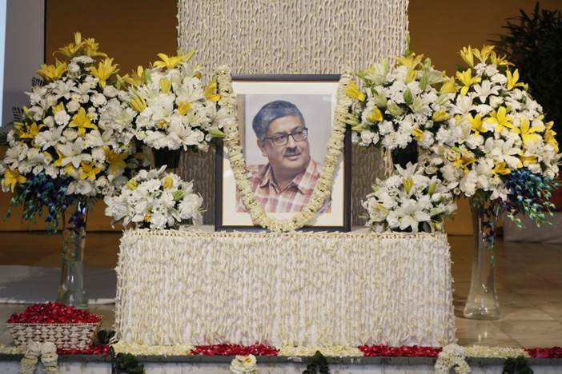

Photo 1 : Ceremony to celebrate the life and achievements of Disability Rights Crusader, Mr. Javed Abidi, photo Credit: NCPEDP (DPI India)

## NEWS FROM UN HEADQUARTERS

**[United Nations conferences/meetings]**

**UN Statistical Commission: Discussion on disability statistics and data**

A panel discussion on disability statistics and data was organized by United Nations Statistics Division (UNSD) and the Washington Group on 7th March 2018 during the 49th Session of the UN Statistical Commission in New York.Experts, including UNDESA, addressed some of the main challenges in disability statistics and data, including lack of data on the situation of persons of disabilities to analyse gaps in their participation in education, employment, voting, access to health-care services and public transport, and limited comparable data. UNSD is currently revising the Guidelines and Principles for Development Disability Statistics (2001), which will highlight the importance of instituting a well-coordinated national policy framework, establishing a national statistical programme that responds to policy data needs, measuring of facilitators and barriers to functioning, and strategies for enhancing analysis, accessibility and utilization of data on disability, amongst others. The presentation materials are available at: <https://unstats.un.org/unsd/statcom/49th-session/side-events/20180307-2L-disability/>

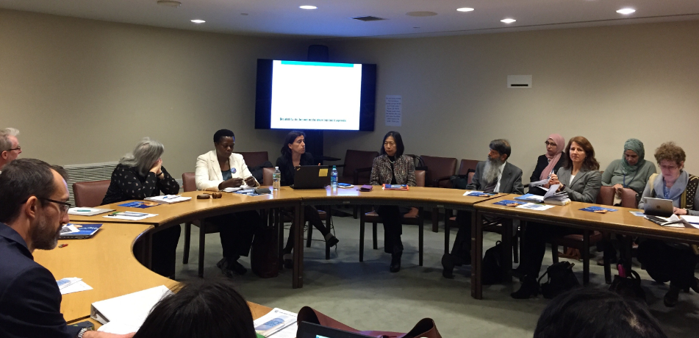

Photo 2: Speakers at the side event on disability statistics

**Commission on the Status of Women (CSW62): Agreed Conclusions**

The [sixty-second session of the Commission on the Status of Women](http://www.unwomen.org/en/csw/csw62-2018),  convened from 12th to 23rd March 2018, adopted the Agreed Conclusions on “Challenges and opportunities in achieving gender equality and the empowerment of rural women and girls” which calls for measures to ensure that women and girls with disabilities have access to inclusive, safe, non-violent and accessible schools with gender- and disability-sensitive infrastructure; equal access to economic and financial resource, accessible social infrastructure, transportation, justice mechanisms and services. It also calls for policies and programmes to fully incorporate the priorities and rights of women and girls with disabilities through close consultation, and to strengthen capacities to collect, analyse and disseminate data, disaggregated by sex, age, disability, among others. More information is available at: <http://www.unwomen.org/en/csw/csw62-2018>

**The Inter-Agency Support Group for the Convention on the Rights of Persons with Disabilities (IASG)**

Annual Face-to-Face Meeting of [the Inter-Agency Support Group for the Convention on the Rights of Persons with Disabilities](https://www.un.org/development/desa/disabilities/about-us/inter-agency-support-group-for-the-convention-on-the-rights-of-persons-with-disabilities.html) was held from 22nd to 23rd March 2018 at the United Nations Entity for Gender Equality and the Empowerment of Women (UN Women), New York. The meeting explored the ways to enhance collaboration an coordination amongst UN entities for the empowerment and inclusion of persons with disabilities, building on experience accumulated, including in connection to  the IASG’s [Strategy and Action Plan of IASG: 2010-2018](http://www.un.org/disabilities/documents/iasg/Strategy%20and%20plan%20of%20action/IASGStrategyPlan23.Feb.2010.doc).

**[United Nations Observances]**

**International Women’s Day 2018**

Observance of International Women’s Day was held on 8 March 2018 at UN headquarters in New York, with a theme of “Time is Now: Rural and Urban Activists Transforming Women’s Lives”. Rural and urban activists took centre stage as Monica Ramirez, Reese Witherspoon, Danai Gurira join the event at the United Nations. The coverage of the event is available at: <http://www.unwomen.org/en/news/stories/2018/3/press-release-commemoration-of-international-womens-day-2018>

**The World Autism Awareness Day, 2 April 2018**

The United Nations General Assembly unanimously declared 2 April as World Autism Awareness Day (A/RES/62/139) to highlight the need to help improve the quality of life of those with autism so they can lead full and meaningful lives as an integral part of society. Commemorations will be held at the UNHQ in New York. Detail can be found at: <http://www.un.org/en/events/autismday/index.shtml>

**NEWS ON REGIONAL INTERGOVERNMENTAL MEETING**

**Protocol to the African Charter on Human and People's Rights on the Rights of Persons with Disabilities in Africa**

The African Union (AU) Assembly of African Union Heads of States and Governments held from 28-29 January 2018 adopted the Protocol to the African Charter on Human and Peoples’ Rights on the Rights of Persons with Disabilities in Africa. The African Disability Protocol (ADP) builds on the rights enshrined in the United Nations Convention on the Rights of Persons with Disabilities and UN charter. The protocol has an African relevance, thrust and the adoption of the ADP is a major success the Africa Disability Alliance and its partners in spearheading and driving the rights of persons with disabilities in Africa. The protocol reflects a legal instrument from an African perspective. More information can be found at: <http://blindsa.org.za/2018/02/13/protocol-african-charter-human-peoples-rights-rights-persons-disabilities-africa/>**;** <http://www.africadisabilityalliance.org/>

***NEWS FROM OTHER UN ENTITIES***

**The Global Study on Children Deprived of Liberty: Call for collaboration and funding**

[The Global Study on Children Deprived of Liberty](http://www.ohchr.org/EN/HRBodies/CRC/StudyChildrenDeprivedLiberty/Pages/Index.aspx) mandated by the General Assembly ([69/157](https://unitednations-my.sharepoint.com/personal/kajima_un_org/Documents/My%20doc%20SCRPD/newsletter/Feb-Mar2018/children%20deprived%20of%20liberty%20because%20they%20were%20in%20conflict%20with%20the%20law,%20and%20children%20deprived%20of%20liberty%20because%20they%20were%20in%20prison%20with%20their%20parents.)), led by an Independent Expert [Professor Manfred Nowak](http://www.ohchr.org/EN/HRBodies/CRC/StudyChildrenDeprivedLiberty/Pages/IE.aspx), is a unique opportunity to improve our understanding and inform policy making on the situation of children who are deprived of liberty, including for disability related reasons. The Global Study will cover the following areas of deprivation of liberty, namely children deprived of liberty in the administration of justice, children deprived of liberty because they are in prison with their parents, migration related detention, deprivation of liberty in institutions, and children deprived of liberty in the context of armed conflict or because they are perceived as a threat to national security. The Global Study will be conducted through a collaborative effort and funded through voluntary contributions. The depth in which these topics will be covered depends on the resources available and for this reason further funding is urgently encouraged. In-kind contributions from UN entities, research institutes, NGOs and others will continue to be of essence, and quality responses to the questionnaire by the Member States will form a vital foundation for data collection and analysis. Interested donors are invited to visit the following website for more information: <http://www.ohchr.org/EN/HRBodies/CRC/StudyChildrenDeprivedLiberty/Pages/Funding.aspx> ; For more information you can also contact: Mr. Georges Younes, Research Coordinator, Ludwig Boltzmann Institute of Human Rights, at [georges.younes@univie.ac.at](mailto:georges.younes@univie.ac.at) ; Or for the UN Task Force on the Global Study on Children Deprived of Liberty: Ms. Sanna Käki, Child Protection Specialist, Office of the Special Representative of the Secretary-General on Violence against Children, at [kaki@un.org](mailto:kaki@un.org)

**True Colours Festival, Singapore City, Singapore**

UNESCO and the Nippon Foundation, in close cooperation with other partners, organized the True Colours Festival, the first Asia-Pacific Celebration of Artistes with Disabilities, which took place from 23 to 25 March 2018 in Singapore City, Singapore. The Festival brought together some of the world’s foremost performing talents with disabilities and UNESCO’s Artistes for Peace. This festival of music, dance and the arts featured an international conference, an outdoor festival of inclusion, community outreach activities, and a unique, world-class indoor multimedia concert experience. Moreover, the Open Dialogue with Artistes event provided space for dialogue, sharing experiences and elaboration of the Outcome Statement focusing on the Article 30 “Participation in cultural life, recreation, leisure and sport” of the United Nations Convention on the Rights of Persons with Disabilities. More information: <https://truecolours.sg/>

**CALENDAR OF INTERNATIONAL DISABILITY EVENTS**

Please send us information on major international disability events, for possible inclusion in the list below, to [enable@un.org](mailto:enable@un.org). Also available on the UN Enable website at: <http://bit.ly/1syHQs2>

**11 April 2018, 5pm-6pm: The 2018 Fordham Distinguished Lecture on Disability, Disability & Innovation: The Universal Benefits of Inclusion, in Keating 1st Auditorium, Fordham University, New York**

The guest speaker: Ms. Haben Girma.The first Deafblind person to graduate from Harvard Law School, Ms. Girma advocates for equal opportunities for people with disabilities. President Obama named her a White House Champion of Change, and Forbes recognized her in Forbes 30 Under 30. Haben travels the world consulting and public speaking, teaching clients the benefits of fully accessible products and services. *The event will have ASL interpretation, CART services, and be wheelchair accessible. F*or any disability access or accommodation question, please contact at [disabilitycluster@fordham.edu](mailto:disabilitycluster@fordham.edu) . RSVP at <https://girmalecture.eventbrite.com>

**16-17 April 2018: Conference on political participation of women with disabilities**, **OSCE Office for Democratic Institutions and Human Rights (ODIHR), Vienna, Austria**

The conference will serve as a platform to raise awareness of the limited participation of women with disabilities in political life and identify positive measures which can facilitate more diverse and inclusive democratic institutions and parliaments, including through ensuring a closer co-operation with women’s networks and organizations. The event will be attended by prominent activists in the field of disability rights and gender equality, politicians with and without disabilities, representatives from organisations of persons with disabilities (DPOs) and experts from other international organizations. DPOs are invited to participate in an NGO fair to present their work. To register for the event and for more information, visit: www.osce.org/odihr/374362 ; contact: [anete.erdmane@odihr.pl](mailto:anete.erdmane@odihr.pl)

**9 May 2018, 3-5pm: Berkeley Forum on Access and Disability Rights, Ed Roberts Campus, 3075 Adeline St, Berkeley, CA, US**

The Forum will discuss progress on and challenges to access for persons with disabilities who visit, live, and work in Berkeley. Panelists include Karen Nakamura, Haas Distinguished Chair in Disability Studies, U.C. Berkeley; Silvia Yee, Senior Staff Attorney, the Disability Rights Education and Defense Fund (DREDF); and Rita Maran, Moderator and Subcommittee Chair CRPD. Contact: Shallon Allen, Secretary, Commission on the Status of Women, City of Berkeley at: [sallen@cityofberkeley.info](mailto:sallen@cityofberkeley.info)

**11-13 May 2018: World Disability Union Programme, Mersin, Turkey**

The three-day meeting will include the General Assembly and side events on 11-May; Accessible Tourism Global Congress on 12-May; and Accessible Schools Inclusive Education Congress on 13-May. More information: [www.whf.org.tr](http://www.whf.org.tr) ;

[www.worlddisabilityunion.org](http://www.worlddisabilityunion.org)

**11 - 13 June 2018: The 7th M-Enabling Summit in Washington, D.C.**

The M-Enabling Summit Conference and Showcase is an annual meeting for all who create and contribute to accessible ICT products, services and consumer technologies. With its 2018 theme of “Accessible and Assistive Technologies Innovations: New Frontiers for Independent Living”, the 2018 M-Enabling Summit will provide a platform for empowering technologies and focus on next-generation innovations and breakthroughs for users of all abilities. It also includes the International Association of Accessibility Professionals (IAAP) Annual Conference. For registration and more details, visit <http://m-enabling.com/>

**24 July 2018: Global Disability Summit, London at the Queen Elizabeth Olympic Park, U.K.**

The UK Department for International Development (DFID), the Government of Kenya and the International Disability Alliance (IDA) will co-host the UK’s first Global Disability Summit in July 2018. The Global Disability Summit is an opportunity to build on the current momentum on disability inclusive development. It provides a platform to secure financial and political commitments by national governments, bilateral and multilateral donors, the private sector and civil society organisations. More information is available at: <https://www.internationaldisabilityalliance.org/uksummit-dpos>

**25 - 27 July 2018: Down Syndrome International’s World Down Syndrome Congress, in Glasgow, UK.**

The Congress brings together people who have Down syndrome, their families, carers and others who have an interest in their lives, to look at new or emerging research and good practice, as well as to hear exciting developments in the lives of people with Down syndrome. Registration open at <http://wdsc2018.co.uk/>

**23 – 27 July 2019 XVIII World Congress of the World Federation of the Deaf, Paris, France**

The Congress theme, "Sign Language Rights for All" as the overarching theme of the XVIII World Congress of the World Federation of the Deaf highlights that full enjoyment of linguistic rights is vital in facilitating the full inclusion of the Deaf Community within society. For more information, visit: <https://www.wfdcongress2019.org/>



*Photo 3: Flyer of the XVIII World Congress of the World Federation of the Deaf, Paris, 23 – 27 July 2019*

**OTHER NEWS**

(DISCLAIMER: The information below is provided by other stakeholders for informational purposes only. This does not constitute endorsement of, or an approval by, the United Nations of any of the products, services, or opinions of the organization or individual. The United Nations bears no responsibility for the accuracy, legality or content of their statements and opinions.)

***[Global meetings]***

**World Urban Forum 9, Kuala Lumpur**

From February 7th until the 13th, representatives of civil society, government (national, sub-national, and regional), private sector and academia from around the world met in Kuala Lumpur for the ninth session of the World Urban Forum (WUF9). The WUF9 mobilized these stakeholders in urban development to discuss their best practices, inputs on monitoring and evaluation, and facilitate strategic partnerships for the effective implementation of the New Urban Agenda. GAATES was actively involved in the Forum, through pre-planning and onsite coordination with 25 members of the Disability Inclusive and Accessible Urban Development Network (DIAUD), organizing and co-sponsoring various events. More information on the outcome of WUF9 can be found at:

<http://globalaccessibilitynews.com/2018/03/07/world-urban-forum-9-kuala-lumpur/>

**Second Global Action on Disability Network meeting**

The Global Action on Disability (GLAD) Network met in Helsinki from 31 January to 2 February 2018 in the House of Estates, Helsinki, Finland. The meeting was co-hosted by the Ministry for Foreign Affairs of Finland & the Abilis Foundation. The GLAD co-chairs, the International Disability Alliance and the Australian Department for Foreign Affairs and Trade, issued communique following the GLAD meeting in Helsinki. More information: contact [glad@ida-secretariat.org](mailto:glad@ida-secretariat.org).

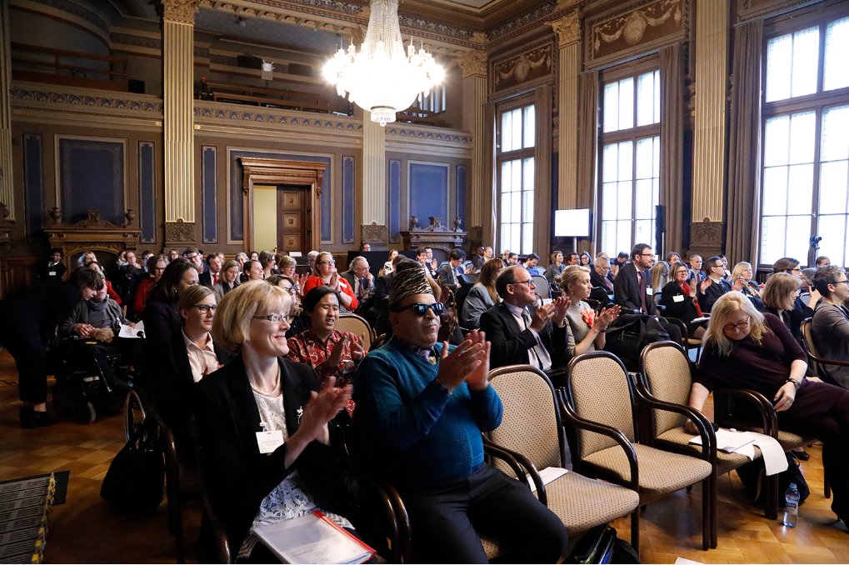

Photo 4 GLAD Network members at the opening of the second Network meeting in Helsinki, 31 January 2018. Photo credit: ©PaolaGuzmánFigueroa (Abilis)

***[Publications/Newsletters]***

**European Human Rights Report on 2030 Agenda**

The European Disability Forum (EDF) presented its second human report entitled “2030 Agenda and Sustainable Development Goals (SDGs) report: A European perspective to respect, protect and fulfil the United Convention on the Rights of Persons with Disabilities”. The report provides an overview of the strong link between the CRPD and the SDGs and presents recommendations on how to ensure Europe takes a human rights based approach to the Sustainable Development agenda, fully including persons with disabilities. This report, presented during the [SDGs conference](http://www.edf-feph.org/newsroom/news/sustainable-development-must-be-inclusive-persons-disabilities), has been designed as a resource for organisations of persons with disabilities and decision-makers in Europe to learn more about the 2030 Agenda and what opportunities exist for advocacy around the SDGs in order to respect, protect and fulfil the CRPD, in Europe and in international cooperation. The board members of EDF agreed to adopt a [resolution](http://www.edf-feph.org/sites/default/files/edf_resolution.doc) where they call on the EU to fully include persons with disabilities in all policy dialogues regarding the SDGs, in Europe and in the context of international cooperation.The report can be downloaded at: <https://bit.ly/2pK74Vc>

**Leveraging Technology for Greater Access to Justice**

The Global Initiative for Inclusive ICTs (G3ict) has published a paper on how courts and justice systems can leverage technology to support greater access to justice for persons with disabilities. The paper recommends eight strategies, including: amending existing legal frameworks to promote equality in courts and justice systems; training leaders and staff to better design and implement ICT accessibility strategies; using the “power of the purse” to advance equality by purchasing only accessible courtroom technology; and involving persons with disabilities at each step in the process. This follows the statement that G3ict made on the same issue to the Committee on the Rights of Persons with Disabilities. As a next step, G3ict will soon announce an online survey to gather additional insight and perspective on this topic and is partnering with the International Disability Alliance to deploy it broadly to Organizations of Persons with Disabilities (DPOs). Website: <http://g3ict.org/>

**Let Me Decide and Thrive, a report on access to sexual and reproductive health and rights**

In December 2017, Plan International launched *Let Me Decide and Thrive* - a report on recent research regarding discrimination and exclusion of girls and young women with disabilities and their access to sexual and reproductive health and rights (SRHR). The report calls for all girls and young women with disabilities to be provided accessible information and services, including comprehensive sexuality education so they can make conscious choices about relationships and sexuality. It also calls for governments to eliminate the stigma and discrimination that prevent girls from accessing the services and information they need about sexual and reproductive health. The report is available at: <https://plan-international.org/publications/let-me-decide-thrive-srhr-disability>

**Launch of Disability Rights Defenders Newsletter**

Independent Living Institute launched the newsletter that links persons with disabilities and their organizations, Human Rights lawyers, law students and their instructors as well as government entities interested in using strategic litigation in implementing the UN CRPD and other international and national legislation. In the free quarterly newsletter shares news such as court decisions, announcements, events concerning disability rights; discusses legal issues regarding disability-based discrimination and implementing the rights of persons with disabilities; presents experts, examples of coalitions and campaigns. Subscribe from: <https://bit.ly/2ufy2Zn> ; Contact: Adolf Ratzka ([adolf.ratzka@independentliving.org](mailto:adolf.ratzka@independentliving.org))

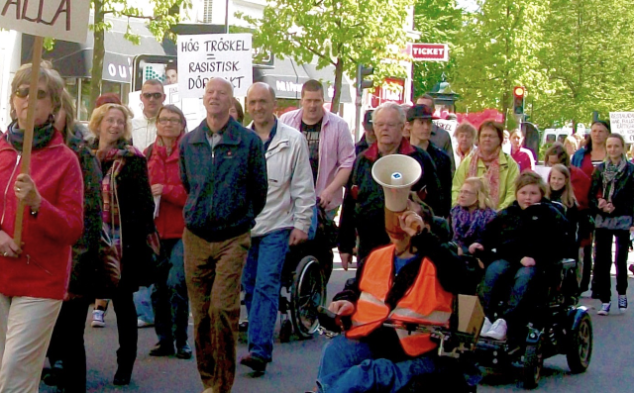

Photo 5 Are we ready to take our fight into the court room? Photo credit: Emil Erdtman

***[Useful tools]***

**Global Map of Women's & Disabilities Rights Advocates and Organizations**

Women Enabled International’s Global Map of Advocates for the rights of women and girls with disabilities continues to grow.  This interactive map, along with its accompanying appendices, highlights hundreds of organizations that work to advance the rights of women and girls with disabilities worldwide.  Since its release in March 2016, over 620organizations have been added. Global Map of Advocates can be found at: <https://www.womenenabled.org/mapping-results.html>

**Mobile App: Voice of Specially Abled People (VoSAP)**

Voice of SAP is an Actionable Advocacy mobile App for Empowering Specially Abled People or Persons with Disabilities. It allows for crowd sourced data on accessibility, pledges of their leaders and community members, solutions, and issues news on disability. VoSAP volunteer team worked with an Indian bank – Bank of Baroda (BoB), which resulted in making BoB branches wheelchair accessible. The VoSAP App can be downloaded at: [Appstore for iOS](https://itunes.apple.com/us/app/voice-of-sap-vosap/id1265835335?ls=1&mt=8) or [GooglePlay for Android](https://play.google.com/store/apps/details?id=com.vosap&hl=en) ; More information on BoB initiative can be found at: <https://bit.ly/2Ee4HhL> ; Story behind the development of the App is available at: <https://bit.ly/2In4sDG>

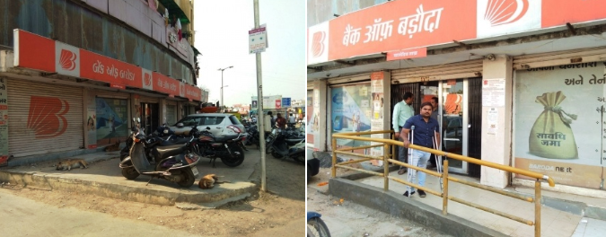

Photo 6: Bank of Baroda – Ghatlodiya Branch – Before and After, Photo: Pranav Desai

**The guide to attending a sporting event for persons with disabilities**

The guide that provides information on accessibility at sports venues in the U.S., such as stadiums and arenas is available online. More information about the guide can be found at: <https://www.sportfacts.org/guide-to-attending-a-ballgame-for-disabled-special-needs-senior-citizens/>

***[Call for inputs]***

**A call for papers:  Artificial Intelligence and Disabilities - Theory, Research and Practice**

The Editors of Assistive Technology are soliciting papers for a special issue that will be devoted to the recent rise in development and research regarding Artificial Intelligence (AI) technologies and their relevancy to promoting quality of life and social inclusion of people with disabilities. For more information please visit: <https://bit.ly/2FZ6ahB>

**CONTACT INFORMATION**

Secretariat for the Convention on the Rights of Persons with Disabilities

Division for Social Policy and Development (DSPD)

Department of Economic and Social Affairs (DESA)

United Nations Headquarters, New York, NY 10017, USA

### BE INFORMED! GET INVOLVED!

Facebook: [www.facebook.com/pages/United-Nations-Enable/196545623691523](http://www.facebook.com/pages/United-Nations-Enable/196545623691523)

Twitter: <http://twitter.com/UN_Enable>

Website: [www.un.org/disabilities](http://www.un.org/disabilities)

Email: [enable@un.org](mailto:enable@un.org)

**Call for volunteers to translate the UN Enable newsletter in other languages**

Volunteer your time to translate the UN Enable newsletter in an official UN language or your own local language. We are looking for volunteers to translate the newsletter in to the UN official languages of **Chinese** and **Russian**.

(<http://bit.ly/enablenewslettervolunteer>)

**Call for photos for future inputs**

We will continue working to improve the design of our newsletter while ensuring the accessibility. We welcome your feedback.

---

**To subscribe:** <http://bit.ly/unenablenewsletter>