UN Enable Newsletter
Special Issue - June 2018

The 11th Session of the Conference of States Parties to the Convention on the Rights of Persons with Disabilities
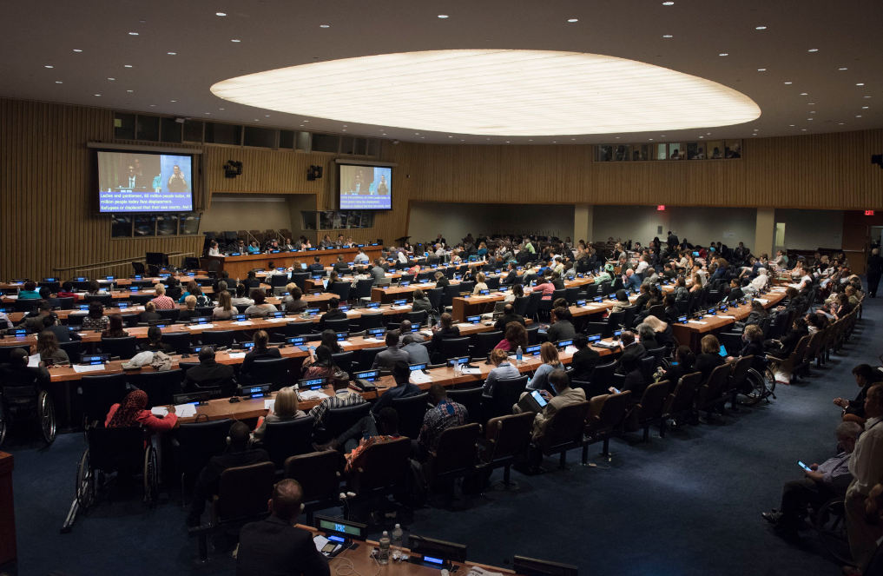
A photo of previous Conference of States Parties to the CRPD, a conference room filled with participants
Photo credit: UN Photo/Kim Haughton

The 11th session of the Conference of States Parties to the Convention on the Rights of Persons with Disabilities will be held from 12 to 14 June 2018 at the United Nations Headquarters, New York. The session will feature an election of nine members of the Committee on the Rights of Persons with Disabilities, among other agenda items.
Overarching Theme of the Conference:
“Leaving no one behind through the full implementation of the CRPD”
Sub-themes:
1. National fiscal space, public-private partnerships and international cooperation for strengthening the implementation of the CRPD
2. Women and girls with disabilities
3. Political participation and equal recognition before the law
Cross-cutting theme:
Promoting high-quality disability statistics and disaggregation of data by disability status for the full realization of the rights of persons with disabilities
Documents of the Conference:
- Provisional Agenda(English | Français | Español | Русский | عربي | 中文)

- Tentative programme of work can be downloaded from here (as of 6 June 2018). Please note that the programme is subject to change. For the most updated version, visit here.

- Background Notes:
  - Roundtable One: National fiscal space, public-private partnerships and international cooperation for strengthening the implementation of the CRPD (English | Français | Español | Русский | عربي | 中文);

- Roundtable Two: Women and girls with Disabilities (English | Français | Español | Русский | عربي | 中文);

- Roundtable Three: Political participation and equal recognition before the law
(English | Français | Español | Русский | عربي | 中文);

- PaperSmart Portal (for document/statements; queries: papersmart4@un.org)

Information on the election of the Members of the Committee on the Rights of Persons with Disabilities can be found at the OHCHR’s website.

- Guidance note on the General Debate can be found from here.

Side events
The list of side events is posted online. Download from here (as of 6 June 2018). Please note that the list is subject to change. For the most updated version, visit here.
Accessibility:
The United Nations Secretariat is committed to promote accessibility and provisions of reasonable accommodation within the UN system.
The Accessibility Centre at UN Headquarters provides equipment and services to delegates and NGO participants at the Conference. Devices can be borrowed by submitting a valid Photo ID and are for use on UN premises only.
The Accessibility Centre will extend its opening hours during the COSP11 as follows:
11 June, 9:00 a.m. – 6:30 p.m.
12 June: 8:00 a.m. – 6:30 p.m.
13 June: 9:00 a.m. – 6:30 p.m.
14 June: 9:00 a.m. – 6:30 p.m.
(Queries? Contact: AccessibilityCentre@un.org)
The products and services available include:
- List of Devices available at the Accessibility Centre can be downloaded from here.
- Wheelchair charging provisions at various locations around UN Headquarters
- Staffed desk to provide an assistance on borrowing and using the devices
Devices are loaned daily on a first-come, first-served basis. Devices are in limited quantity and must be signed for and returned on the same day no later than 5:00 p.m.
The Conference website:
For more information on the COSP11, please visit the following link:
https://www.un.org/development/desa/disabilities/conference-of-states-parties-to-the-convention-on-the-rights-of-persons-with-disabilities-2/cosp11.html

CONTACT:
Programme on Disability/Secretariat for the Convention on the Rights of Persons with Disabilities
Division for Inclusive Social Development (DISD)
Department of Economic and Social Affairs (DESA)
United Nations Headquarters, New York, NY 10017, USA

BE INFORMED! GET INVOLVED!
Facebook: www.facebook.com/pages/United-Nations-Enable/196545623691523
Twitter: http://twitter.com/UN_Enable I Website: www.un.org/disabilities I Email: enable@un.org

Call for volunteers to translate the UN Enable newsletter in other languages
Volunteer your time to translate the UN Enable newsletter in an official UN language or your own local language. We are looking for volunteers to translate the newsletter into the UN official languages of Chinese and Russian.
(http://bit.ly/enablenewslettervolunteer)

Call for photos for future inputs
We will continue working to improve the design of our newsletter while ensuring the accessibility. We welcome your feedback.
---
To subscribe: http://bit.ly/unenablenewsletter

