INDIGENOUS MEDIA ZONE
DRAFT PROGRAMME
24-28 April 2017

UN Correspondents Association Room
UN Secretariat, 3rd floor
(take the escalator from the 1B level)

Monday, 24 April 2017
Time | Event | Speakers
1:00-1:30 p.m. | The Right to Information (Spanish)  Indigenous women's access to media and digital media, and innovative approaches to protecting indigenous cultures and languages. | Guadalupe Martínez Pérez Nuhua (México)
3:00-3:30 p.m. | Facebook Live (English) www.facebook.com/joinundesa  10 Years of the Declaration on the Rights of Indigenous Peoples  A conversation with an indigenous elder and an indigenous youth: How far have we come – where do we go from here?  Moderated by Myrna Cunningham | Willie Littlechild (Canada)  Indigenous Elder  Åsa Larsson-Blind (Sweden) Indigenous Youth

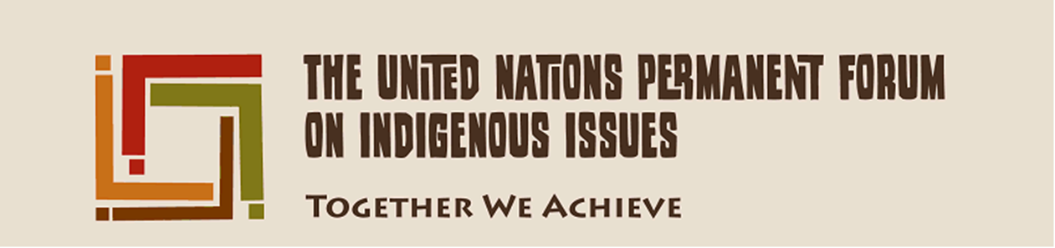

Tuesday, 25 April 2017
Time | Event | Speakers
1:00-1:30 p.m. | Indigenous rights for all English)  Inclusiveness of indigenous peoples’ rights: women’s rights, rights of persons with disabilities, and others  Moderated by Alma Temaj | Chandra Roy-Henriksen  Chief, Secretariat of the UN Permanent Forum on Indigenous Issues  Nidia Rosmery Bustillos  Quechua (Bolivia)
2:00-2:30 p.m. | Violence against indigenous women and girls (English)  New challenges and strategies to combat violence  Moderated by Isabel Flota | Nadia Fenly  Observatorio de Mujeres Indigenas contra la Violencia (Obervatory of Indigenous Women against Violence)  Monica Michelena  (Uruguay)
3:00-3:30 p.m. | Facebook Live (Spanish) www.facebook.com/joinundesa  A conversation with indigenous Members of Parliament (Conversación con Congresistas Indígenas)  Moderated by Tarcila Rivera | Tania Pariona Tarqui  Member of Congress, Peru  Lourdes Tiban Guala  Member of Congress, Ecuador
4:00 – 4:30 p.m. | Indigenous Women and Female Genital Mutilation  Moderated by Isabel Flota | Severina Lemachokoti  (Samburu, Kenya)
4:30 – 5:00 p.m. | A Conversation with Indigenous Experts | Victoria Tauli-Corpuz  Special Rapporteur on the rights of indigenous peoples  Álvaro Esteban Pop  Former President, UN Permanent Forum on Indigenous Issues

Wednesday, 26 April 2017
Time | Event | Speakers
9:00 – 9:30 a.m. | Inclusion of indigenous peoples in censuses and the development of relevant indicators to monitor the SDG (English)  Moderated by Lola García | Joji Cariño  Forest Peoples Programme (Philippines)  Martin Oelz  International Labour Organization
9:30-10:00 a.m. | Facebook Live (English) www.facebook.com/joinundesa  The struggle over indigenous lands and territories  Moderated by Joan Carling | Brenda White Bull  (Lakota, United States)  Cristina Coc  (Ketchi Maya, Belize)  Bidhayak Chakma  (Chittagong Hill Tracts, Bangladesh)  Joji Cariño  Forest Peoples Programme (Philippines)
1:00-1:30 p.m. | The Right to Development (El derecho al desarrollo) (Spanish)  Moderated by Guadalupe Martínez | Pedro Posadas  President, Fund for the Development of Indigenous Peoples of Latin America and the Caribbean  Álvaro Esteban Pop  Former President, UN Permanent Forum on Indigenous Issues
4:00-4:30 p.m. | Cultural and natural diversity: International Year of Indigenous Languages (2019) (English) | Edna Kaptoyo (Pokot, Kenya)  Celerina Patricia Sánchez Santiago (Mexico)

Thursday, 27 April 2017
Time | Event | Speakers
9:00-9:30 a.m. | Economic Empowerment of Indigenous Women and Youth (English)  Moderated by Guadalupe Martínez | Antonella Cordone (IFAD)  Joan Carling (Philippines)  Dali Ángel (Zapoteca, Mexico)
10:30 – 11:00 a.m. | Facebook Live (Spanish) www.facebook.com/joinundesa  Indigenous rights in Mexico City’s Constitution  (Derechos indígenas en la constitución de la Ciudad de México)  Moderated by Myrna Cunningham | Miguel Ángel Mancera Espinosa  Mayor of Mexico City  Porfirio Muñoz Ledo, Commissioner for the Political Reform of Mexico City  Mardonio Carballo Manuel, Indigenous Representative
2:00-2:30 a.m. | Indigenous Women in Africa (French)  Challenges faced by indigenous women, and their roles in post-conflict situations | Mariam Wallet Aboubakrine Chair of the UN Permanent Forum on Indigenous Issues (Mali)
2:30-3:00 p.m. | Indigenous Peoples in Russia (English / Russian) | Rodion Sulyandziga  Director, Center for the Support of Indigenous Peoples of the North (Russia)

Friday, 28 April 2017
Time | Event | Speakers
9:30-10:00 a.m. | Facebook Live (English) www.facebook.com/joinundesa  Indigenous Youth – walking between two worlds  Moderated by Albert Barume (TBC) | Atama Katama (TBC)  Global Indigenous Youth Caucus (Asia)  Duane Fraser  Global Indigenous Youth Caucus (Australia)  Sarah Lynn Jancke  Global Indigenous Youth Caucus (Arctic)  Wienne Kodi (TBC)  Global Indigenous Youth Caucus (Africa)  Q”apaj Conde (TBC)  Global Indigenous Youth Caucus (Latin America)
1:00-1:30 p.m. | Signing of an Agreement between Transparency International and the Fondo para el Desarrollo de los Pueblos Indígenas de América Latina y El Caribe (FILAC) (Spanish)  Moderated by Myrna Cunningham | Álvaro Esteban Pop (TBC) (Guatemala)  Manfredo Marroquin, Transparency International  Special Prosecutor of Guatemala (TBC)  Vice-President of Costa Rica (TBC)
1:30 – 2:00 p.m. | Indigenous Peoples and Natural Resources (English)  The issues of salmon and fishing rights  Moderated by Nidia | Anne Nuorgam (Saami, Finland)  Jens Dahl (Denmark) (TBC), Vice-Chair of the UN Permanent Forum on Indigenous Issues
2:00-2:30 p.m. | Strategies and actions to promote the participation of indigenous peoples (English) | Indigenous representative from Asia (TBC)  Elifuraha Laltaika (Tanzania)  Indigenous representative from Latin America (TBC)  Terri Henry (TBC), Vice-Chair of UNPFII who will be focal person for the process on participation

