PANELLISTS’ BIO |   Open-ended Working Group on Ageing  Fifth working session  New York, 30 July - 1 August 2014  CR1 (CB)

Panel 1
Human Rights and Care of Older Persons

 | Ruthe Isden  Public Services Programme Director  Age UK  Ruthe works for Age UK, the UK’s largest charity working on behalf of people in later life, as the Health Influencing Programme Director managing the organisation’s external advocacy work on healthcare.  In addition to her role within Age UK, Ruthe provides strategic support and advice to a range of external bodies and independent initiatives including the Dignity in Care Partnership, the Malnutrition Task Force and the Richmond Group of Charities and is a member of the editorial board for the Journal of Nursing Older People. Most recently she has spent six months embedded with the NHS England Nursing Directorate to support on development of their older people’s strategy.  Ruthe joined the organisation as the Health and Social Care Programme Manager in 2010 having previously worked within Parliament as a senior policy advisor before moving on to lead the policy secretariat at the British Dental Association.  Ruthe’s policy interests include health and social care integration, public service reform in the context of an ageing population and improving patient experience.
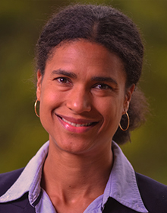 | Isabella Aboderin  Head of Ageing and Development Program  African Population and Health Research Center  Isabella is the Regional Chair for Africa of the International Association of Gerontology and Geriatrics (IAGG), Technical Advisor to the Global Commission on Aging in Developing Countries, Member of the World Economic Forum Global Agenda Council on Aging Societies, Board Member of HelpAge International, and Advisory Board member of the World Demographic and Aging Forum (WDA). Isabella also serves on the African Commission on Human and People’s Rights Working Group on the Rights of Older Persons in Africa.  She holds a PhD from the School for Policy Studies from the University of Bristol, UK, an MSc in Health Promotion Sciences from the London School of Hygiene and Tropical Medicine, and a BSc in Cellular and Molecular Pathology from the University of Bristol.  Isabella’s research interest centers on the nexus between issues of aging and older persons and core development agendas in Africa, with a focus on age-based inequities in wellbeing and service access, older persons’ economic and intergenerational roles and the life course of younger generations. Her research is driven by a conviction that issues of aging not only affect us individually and in families, but are crucial for the future of Africa’s societies.
Panel 1 (continued)
Human Rights and Care of Older Persons

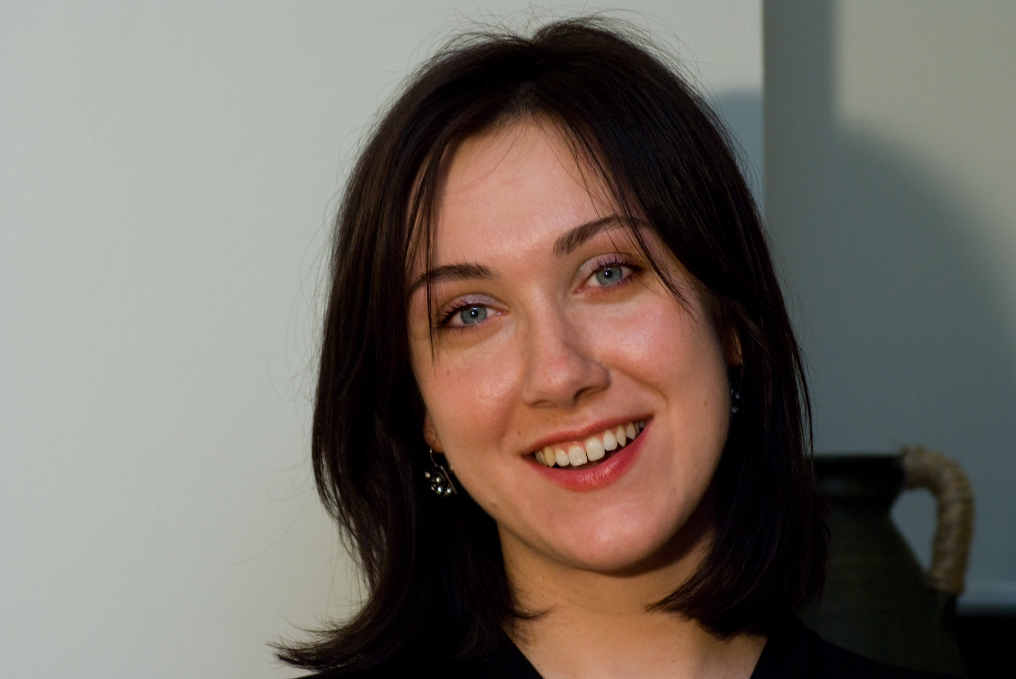 | Kasia Jurczak  Policy Analyst, European Commission  Kasia works as a Policy Analyst in the Social Protection Unit of the European Commission's Directorate General for Employment, Social Affairs and Inclusion. She is part of the team responsible for policy development in the areas of Health, Long-term care and disability, as well as for follow-up to the European Year for Active Ageing and Solidarity between Generations (2012).  Prior to joining the European Commission in August 2012, she worked at the European Union Agency for Fundamental Rights (FRA) in Vienna, where, as Programme Manager, she coordinated work on disability rights, focusing on independent living, participation, accessibility and disability mainstreaming. She also played an important role in the process of establishing the Agency as the UN CRPD Article 33 monitoring body at the EU level.  Kasia previously worked for Eurofound, a Dublin-based EU agency, as a Research Officer on working conditions and social dialogue and for EuroHealthNet, a network of public health agencies, coordinating projects on health inequalities, social exclusion and public health capacity building in Central and Eastern Europe. She also consulted for the UNDP and the OSCE in the areas of social development and democratisation.  Kasia studied Social Policy with Social Psychology at the London School of Economics and Political Science (BSc) in the UK and Comparative Social Policy at the Catholic University of Leuven (MA) in Belgium.  Kasia is a Polish national and in addition to her mother tongue, she speaks English, French and some German.
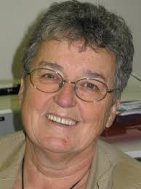 | Mateja Kožuh Novak  President, Slovenian Federation of Pensioners' Organizations  Mateja has served as President of the Slovenian Federation of Pensioners' Organisations (ZDUS) since 2004. She is responsible for the day-to-day performance of ZDUS including activities of committees, working groups and projects on national and international level, promoting visibility and communication with all local and regional associations.  From 1993 until 1996 Mateja served as a member of Slovenian Parliament. She was Vice Chairwoman of the Committee for Health, Labour, Family and Social Policy. From 1988 until 1992, she was the Director of the Slovenian National Institute for Social Medicine and Social Welfare. Her responsibilities included monitoring the performance of national health statistics and co-ordination of the national programme on health promotion and education.  Mateja has over 15 years of experience in the co-ordination of NGO’s and running voluntary work projects. She holds a Doctor of Science in Gynaecological Epidemiology from the University of Ljubljana, Slovenia and a Master’s degree in Public Health from Johns Hopkins University.
Panel 2
Violence and Abuse Against Older Persons (older women, financial abuse)

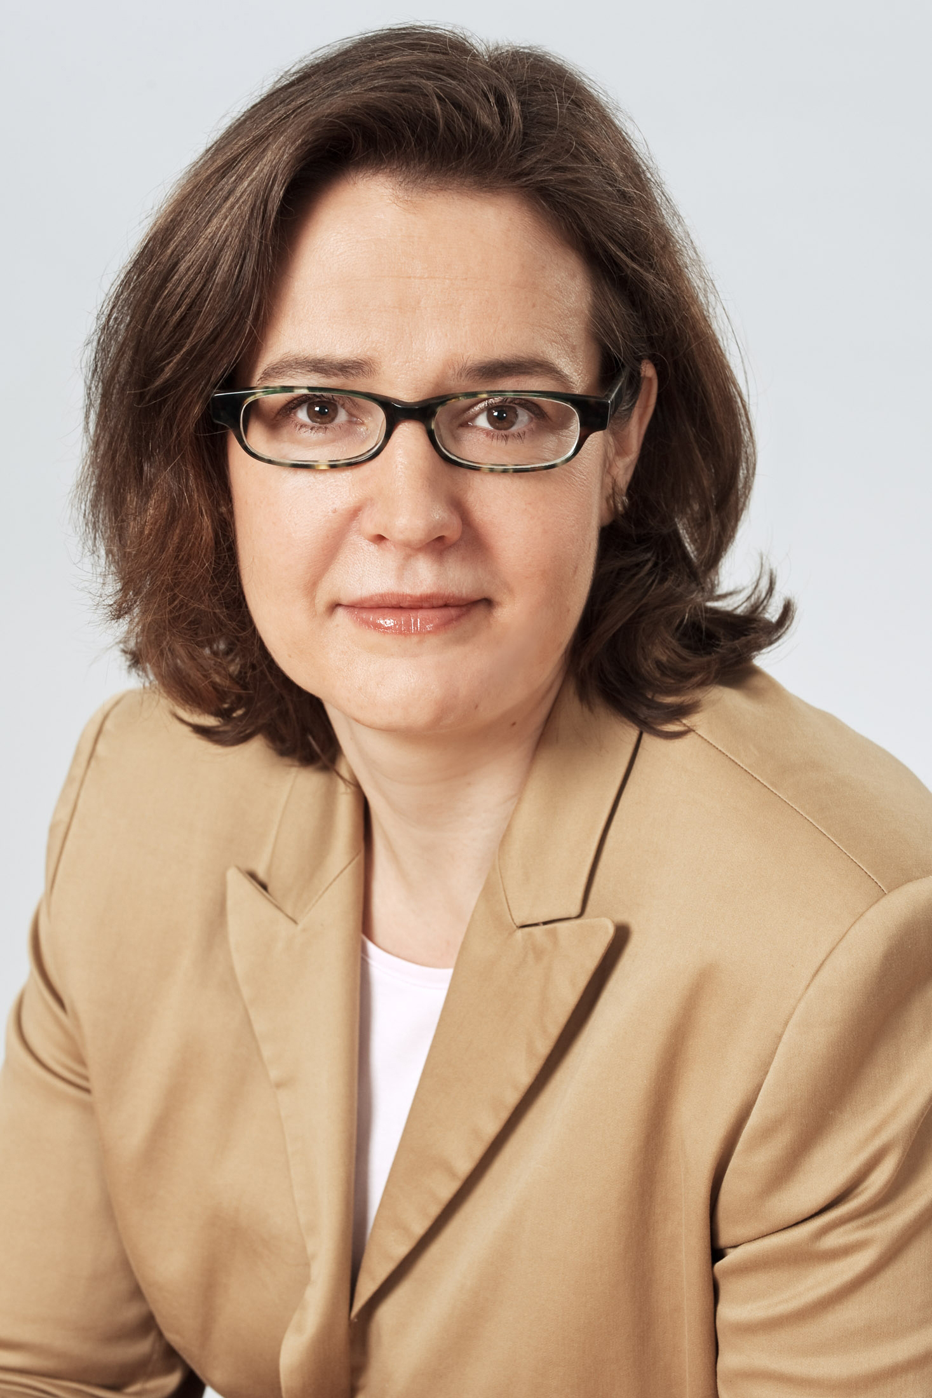 |  | Claudia Mahler  Senior Researcher, German Institute for Human Rights  Claudia has been working for the German Institute for Human Rights as a senior researcher in the field of economic, social and cultural rights since 2010.  She has conducted research on human rights and related issues at the Human Rights Centre of the University of Potsdam (2001-2009).  During her work in Potsdam her main research fields were human rights education, minority rights and the law of asylum. From 1997-2001 she held the position of an assistant at the Leopold-Franzens-University Innsbruck, Austria in the field of Criminal Law and Criminal Procedures.  Claudia was appointed as Vice President of the Human Rights Commission for Tyrol and Vorarlberg by the Austrian Ministry of Interior from 2000-2002.  Claudia has also worked as a lecturer in the field of human rights law and as a consultant to the Office of the High Commissioner for Human Rights in Geneva.
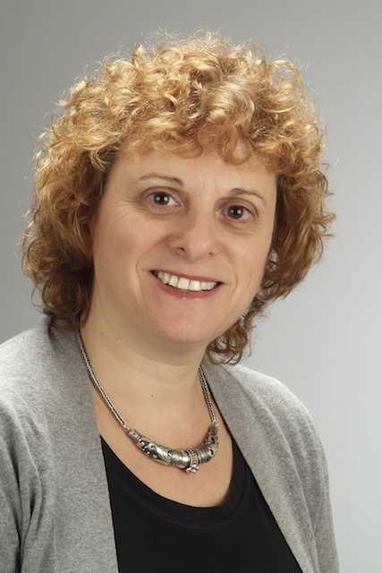 |  | Silvia Perel-Levin  Chair, United Nations NGO Committee on Ageing, Geneva  Silvia is the Chair of the UN NGO Committee on Ageing in Geneva, and is an Independent Consultant on health and communication.  Silvia has been active in the field of health and health promotion for the last 15 years and on elder abuse for the last 13 years. Her main fields of interest have been research on perceptions of elder abuse, detection and screening at the primary health care level and advocacy for active ageing and the rights of older persons.  At the World Health Organization, working closely with the International Network for the Prevention of Elder Abuse (INPEA), Silvia designed and coordinated the first multi-country study on elder abuse and co-wrote the resulting publication “Missing Voices, views of older persons on elder abuse” (2002).  Silvia also launched the “Toronto Declaration on the Global Prevention of Elder Abuse” (2002) and published “Discussing Screening for Elder Abuse at Primary Health Care Level” (2008).  Upon returning to Geneva from Budapest, in 2012, Silvia joined the team representing INPEA and the International Longevity Centre - Global Alliance (ILC-GA) at the UN.
Panel 2 (continued)
Violence and Abuse Against Older Persons (older women, financial abuse)

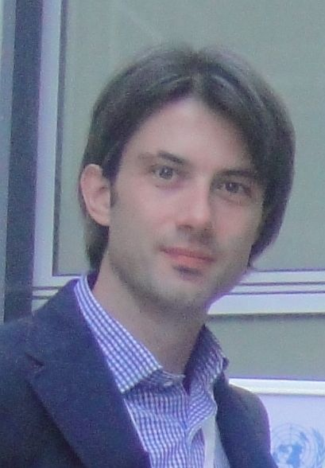 |  | Milutin Vracević  Health and Care Program Manager, Red Cross of Serbia  Milutin is the Health and Care Program Manager at Red Cross Serbia. He graduated from the Medical school of the Belgrade University and is a member of the Serbian Chamber of Medicine.  The Serbian Ministry of Health accredited Milutin as an educator of volunteers on palliative care. He has been working for the Red Cross of Serbia since 2001 as a Programme Manager, working in the Home Care programme where he contributed to the design and was instrumental in the implementation, targeting primarily older vulnerable people. Since 2006, his portfolio in the Red Cross of Serbia has expanded and in addition to continuing with the Home Care programme with an emphasis on advocacy with the emphasis on the issues of abuse and violence.  Milutin has been active in setting up a national network of organisations working with older people, HumanaS, promoting the right based approach in advocating for different issues such as abuse and violence, poverty, accessibility of social and health services. He is also a country co-representative for Serbia of the International Network for the Prevention of Elder Abuse (INPEA).  Milutin was born in 1971 in Belgrade, Serbia, then Yugoslavia.
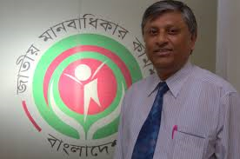 |  | Kazi Reazul Hoque  Commissioner, National Human Rights Commission, Bangladesh  Kazi was appointed by the President of Bangladesh as the Full Time Member of National Human Rights Commission in June 2010 with the privileges and remuneration of High Court Division Judge. He is the Chair of Child Rights Committee, Business and Human Rights Committee, Migrant Workers Welfare Committee of NHRC Bangladesh. He is also the Chief Coordinator of NHRC for the Universal Periodic Review by UN Human Rights Council and Member of Working Group of Asia Pacific Forum of NHRI in the process of formulate on of proposed UN Convention on the Rights of Older Persons.  Kazi had served the government of Bangladesh for thirty years in various capacities including Secretary to the Government. He represented NHRC Bangladesh in many regional and international forum and presented papers on human rights.  After obtained his Master’s Degree in social science from Dhaka University in 1973, Kazi joined in the Bangladesh Civil Service. He did his Post Graduate Diploma in Human Resource Management. He also studied Management, Public Policy, Law in many reputed institutes/universities like Asian Institute of Technology (AIT), Bangkok, Thailand; British Civil Service Collage, Sunningdale, UK; Birmingham University, Birmingham, UK; International Law Institute, Washington DC, USA.
Panel 3
Planning for End of Life Care: Legal and Financial Issues

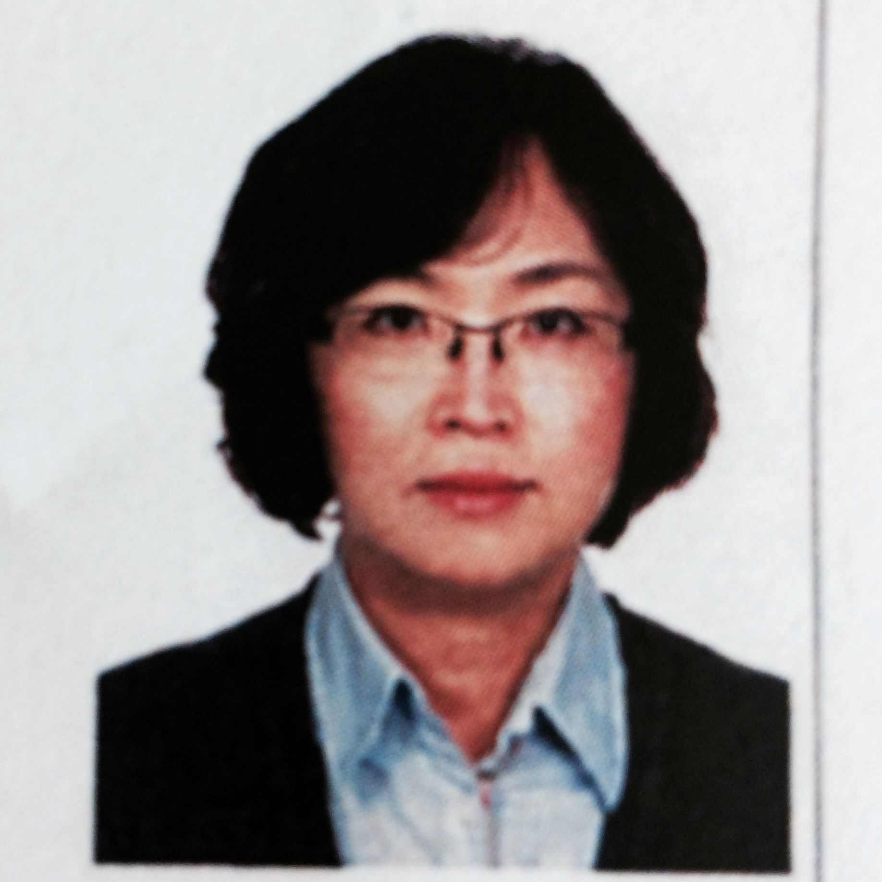 |  | Sooyoun K Han  Founder, Care and Reaching Elders Rights, South Korea  Sooyoun is the founder of Caring & Reaching Elders Rights as well as a professor at Namseoul University in South Korea.  She has been working on organizing and developing programs to improve elderly patients and their family caregivers' autonomy and dignity in end-of-life care since 2012.  Sooyoun’s 10 years of experience in being a medical social worker in a hospital setting in the U.S. has driven her to view Asian elderly patients' rights in end-of-life decision through the human rights lens, and has kept her continuing research for psychoeducational intervention programs to help them in their end-of-life decision making.
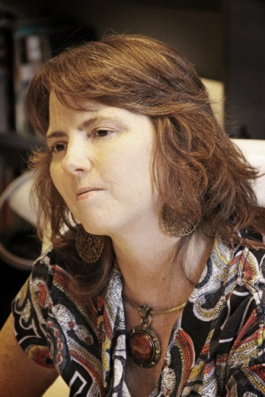 |  | Mónica Roqué  Director of National Policy for Older Persons, Ministry of Social Development, Argentina  Mónica is Director of National Policy for Older Persons (SENNAF) at the Argentinian Ministry of Social Development. She is also the General Coordinator of the National Plan for Older Persons, as well as the President of Argentina's delegation to the UN and OAS working group on human rights convention for seniors. Mónica was also the President of the 2014 Human Rights Council Social Forum in Geneva, as she addressed the topic of ‘Human Rights of Older Persons’. She is the Executive Secretary of the Federal Council of Elders, and the manager of the National Observatory Project od Seniors (OISS) since 2006 to date.  Academically, Mónica is the Director of the graduate career specialization and a full professor in the Community and Institutional Gerontology, Faculty of Psychology of Mar del Plata. Mónica is also a guest lecturer at the University of Buenos Aires, Rosario University and the National University of Córdoba. She is the President of the Latin American Congress of Gerontology Community, held between the Ministry of Social Development, the University of Buenos Aires, the Universidad Nacional de Mar del Plata, and the Institute for Age. She has participated in national and international conferences, and has several publications including co-author of the National Plan for Older Persons; Manual for Home Care, author of the Bill of Rights of the Elderly, the need and rationale for an international treaty of older people "in the rights of the elderly people in the twenty-first century; Government of Mexico and ECLAC – amongst others. Mónica has an MD and a Masters of Health Services from the University of Alcalá, Spain.
Panel 3 (continued)
Planning for End of Life Care: Legal and Financial Issues

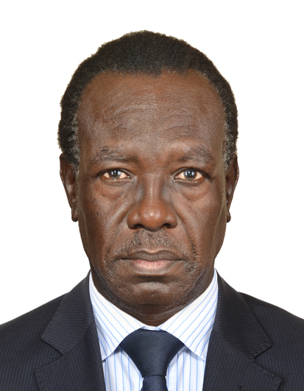 |  | David Obot  Chairman, Board of Directors, Uganda Reach the Aged Association  David is the Chairman of the Board of Directors of Uganda Reach the Aged Association (URAA) for older persons issues. He has experience in research planning and management, advocacy for vulnerable groups, institutional development, conflict analysis and response, planning and managing micro-projects for rural development, and monitoring and evaluation. David has served on various Boards since 1992. Currently, is the Chief Executive Officer of the Network of Ugandan Researchers and Research Users (NURRU); Board Member to: InterAid Uganda (IAU) Ltd. for refugees and conflict issues; Uganda Road Sector Strategic Initiative (URSSI) for roads and road use; Uganda National Commission (UNATCOM) for UNESCO; IGAD - CSO Uganda Chapter for regional development and conflict issues; Civil Society - Private Sector Forum, promoting partnerships & advocacy for social and economic development.  David is also the Chairman of Agwata Town Board Planning Committee, Dokolo District, and the President (2014-2015) of the Rotary Club of Kampala Day Break in Uganda. David has an MA. In Public Administration & Management.
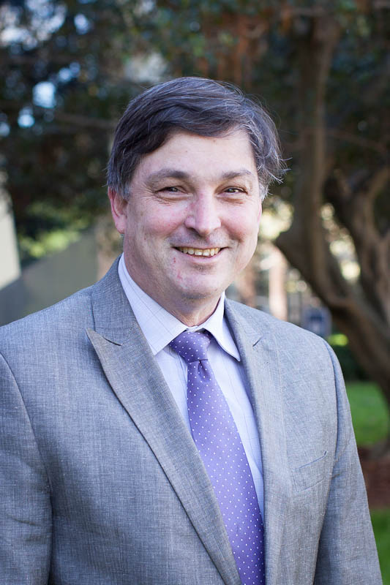 |  | Andrew Byrnes  Professor of Law at the University of New South Wales, Australia  Andrew is Professor of Law at the University of New South Wales, Sydney, Australia, where he is also Chair of the Australian Human Rights Centre based in the UNSW Law School. Previously, he was Professor of Law at the Australian National University (2001-2005) and prior to that was Associate Professor of Law at the University of Hong Kong, where he was Director of the Centre for Comparative and Public Law (1989-2001).  Andrew teaches and writes in the fields of public international law, human rights, and international criminal/humanitarian law. He has served as co-rapporteur of the International Law Association’s Committee on International Human Rights Law and Practice and as a member of the Asian Development Bank’s Forum on Gender and Development, and was closely involved in the drafting of the Hong Kong Bill of Rights, the Optional Protocol to the CEDAW Convention, and the Convention on the Rights of Persons with Disabilities (including as adviser to the Asia Pacific Forum of National Human Rights Institutions).  Andrew served as President of the Australian and New Zealand Society of International Law from 2009 to 2013. He has also served as Co-Editor of the Australian Yearbook of International Law and is a member of the editorial board that journal and of the Australian Journal of Human Rights.  Since November 2012 Andrew has served as external legal adviser to the Australian Parliamentary Joint Committee on Human Rights.

